**Advance Database Management System Lab**

**Experiment- 9**

**To understand the concepts of PL/SQL programming**

**Aryan Mohan**

**500092142**

**Batch- 2**

--1) Write a PL/SQL code to accept the value of A, B & C display which is greater.

BEGIN

DECLARE @A INTEGER;

SET @A =15;

DECLARE @B INTEGER;

SET @B = 65;

DECLARE @C INTEGER;

SET @C =25;

IF @A>@B AND @A>@C

PRINT 'GREATEST IS A';

ELSE IF @B>@C AND @B>@A

PRINT 'GREATEST IS B';

ELSE

PRINT 'GREATEST IS C';

END;

Output:



--2) Using PL/SQL Statements create a simple loop that display message “Welcome to PL/SQL Programming” 20 times

DECLARE @i integer;

set @i=1;

while @i<=20

BEGIN

PRINT 'Welcome to PL/SQL Programming';

set @i=@i+1;

END

Output:

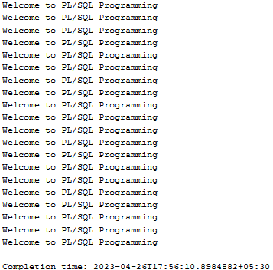

-- 3) Write a PL/SQL code block to find the factorial of a number.

DECLARE @fact integer, @n integer;

set @fact=1;

set @n=6;

while @n > 0

begin

set @fact=@n*@fact

set @n=@n-1

end

print @fact

Output:



--4) Write a PL/SQL program to generate Fibonacci series.

declare @f1 INTEGER=0, @f2 INTEGER=1,@f3 INTEGER,@i INTEGER=3,@len INTEGER;

print 'First two number'

print @f1;

print @f2;

set @len=10;

print 'fibonacci series is';

while(@i<=@len)

begin

set @f3=@f1+@f2;

print @f3

set @f1=@f2;

set @f2=@f3;

set @i=@i+1;

end;

Output:

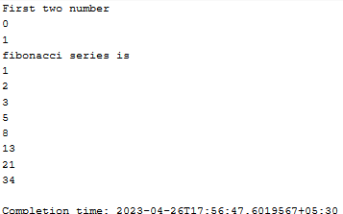

--5) Write a PL/SQL code to fund the sum of first N numbers

declare @n integer, @i integer, @sum integer = 0;

set @i = 1;

set @n=10;

while (@i <= @n)

begin

set @sum=@sum+@i

set @i=@i+1

end

print 'sum of first N=10 numbers'

print @sum

Output:

